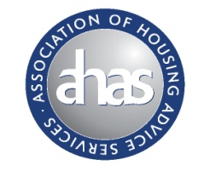
AHAS
AGM 18 March 2015
Camden Town Hall – Council Chamber – Judd Street – WC1H JU

- Minutes of last meeting
- Elections
- Report back
- Future work

AHAS General Meeting 18 March 2015
- Introductions
- Update and discussion on implementation of B/B nightly limits (Chatham House rules will apply)
Ieuan ApRees – West London Region Coordinator
- Universal Credit
- Legal Updates
- News and views roundup
- AOB

